BRO.SIGA SOCIAL SERVICE GUILD (BSSSG)
No.29/16L, Kamaraj Avenue, 1st Pallam Street, Vyasarpadi, Chennai -600 039.

30th Annual Report of BSSSG for the period 2017-2018 presented to the General Body, in its annual meeting held in the office
I am standing before this august assembly of the General Body, to present the annual report, of our organisation. It is with a mixed, feeling of sorrow, and joy that compiled this Report. Sorrow, because, a few projects went out of our hand. For a NGO even if one project goes, out of the hand, it is a great loss. We lost more than one. Joy, because a couple of new funding agencies recognise our partners. I will start with meaning the loss first and then will are joice later
- Terre des Hommes, Netherlands:
We lost our adopted parents. It was Terre des Hommes which brought us up from childhood. When it shifted its area of operation from South India to North India, we lost its patronage, which is very hard to be compensated – A skeletal token project – “Relief of Poor” – Micro loan rotation was continuing which also may vanish soon.
- CHILDLINE FOUNDATION:
As I had stated in my last Report the Ministry of Women and Child Development, through the Childline India Foundation sanctioned two projects for us. One was Railway CHILDLINE help Desk at Chennai Central Railway Station and another North Chennai Collab Child Line Desk. We ran the latter project successfully for a year. Then came the trouble. The Government Grants are released several months after the due date. The expenses the staff salary inclusive, accumulate to a huge amount. We have more than one Government Projects. The amount became unbearable. And we do not have a Reserve fund. So there was no way but to surrender this project.

- Night Shelter for homeless women:
It was a worthy, needy project aided by the Greater Chennai Corporation. We ran it well nearly a year. Then the Corporation wanted to revamp the Project after conducting a resurvey of the needy women under its jurisdiction. So the shelter scheme was temporarily closed.
The United Way of Chennai:
The Chennai Chapter of the United Way sanctioned a project to us, which in essence was promoting the technical education of the disadvantaged youth in the Community College at Uthiramerur, by bearing the staff salary expenses of the college. It went smooth and crossed the first year. Then there was some adverse development among the staff and the donor agency was not inclined to extend the grant.

Thus, you will see that we lost four projects and four donor agencies all due to circumstantial compulsions. I am worried not because of any monitory loss. No financial loss is involved in it. But it is a technical loss. When the total output of BSSSG in its lifetime towards social causes, is calculated, at some point of time, the discontinuation of these four projects, will significantly reduce the quantum of output. That is why I am unhappy.
Now I pass on to the sunny side – joy of partnering with new donors. As a usually do, I divide it into two parts – the Chennai Project, and the Uthiramerur project.

The Chennai Projects

I have arranged all our projects in Chennai under two headings – New projects and continuing projects. I will start with the first

New Projects:
- MOL Bulk Shipping Private Limited – Child Health Initiative Project
It is a Corporate in the Shipping Sector. Under the CSR scheme, a project was sanctioned to improve the child health in Vyasarpadi slums. Creating awareness on the different aspects of child health and distribution of nutritious food to kids are the two components of this project. In the span of last ten months awareness meetings were conducted for different groups of mothers in the slums. Every month a packet of ingredient for nutrient powder is distributed to 500children registered under this scheme. Weight of the child also is recorded every month.
Results
- 698 women were sensitized on environmental hygiene and sanitation, Immunisation, and survival rights - The community people understand about the MOL
- 255 ANC & PNC mothers benefited through awareness programme – Maternal death nil
- All 500 children were immunised on scheduled date and prevented from killer diseases
- All 500 children received supplementary nutritious food packet - 303 out of 500 under weight children increased their age appropriate weight
- Infant Mortality rate –Nil
- 500 children were given new dresses - the children are happy
- 69 volunteers and staff were trained in Child Health Initiative concept
- 174 children benefitted by Medical camps.
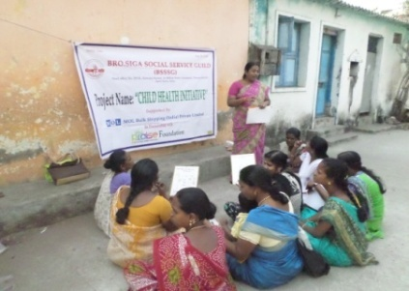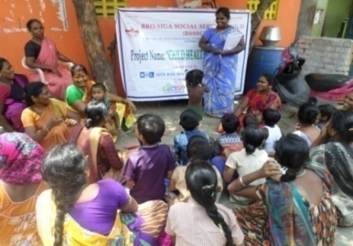
Field staff conduct Awareness meeting to mothers in slum level
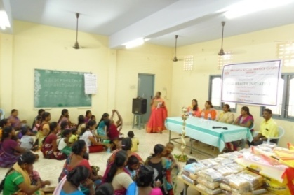 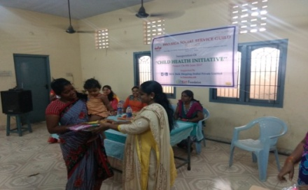Distribution of Dress and Supplementary food to children by Mrs. Rufina from MOL Bulk Shipping Pvt. Ltd. And Director and team from Praise Foundation
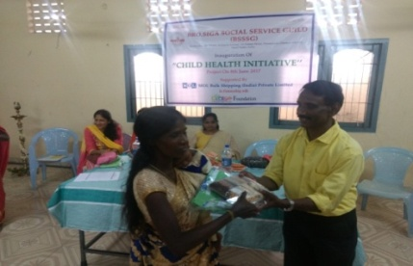
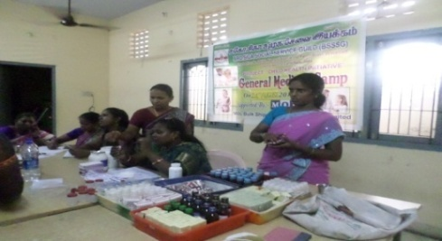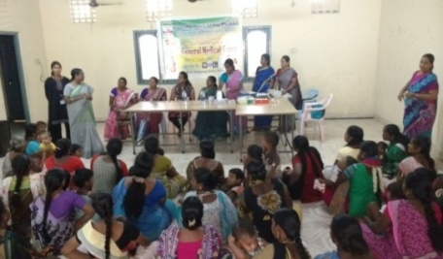
Organised General Medical Camp
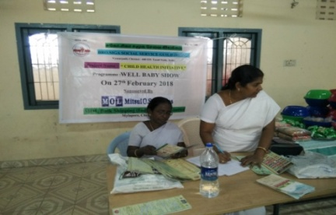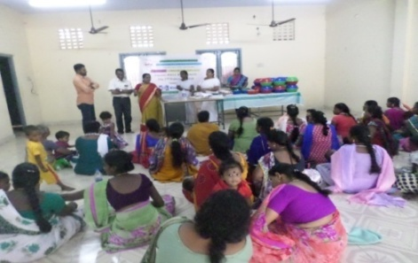
Well baby programme

- Azim Premji Philanthropic initiative:
Azim Premji needs no introduction. His avowed field of Higher Education in now diversified to include child protection also. It is said that the runaway children have in recent times become smarter than the police and child protection workers in the Railway Stations. Hence these children get down at a station, before the terminus and take different routes to reach the city. To cover such children a Satellite Unit is opened now in the stations before the main station. Under this plan a satellite unit at Perambur Railway Station with an Open Shelter for the rescued children was allotted to us. The open shelter functions in the ground floor of the office building. APPI supports this project. 23 staff are working in this programme

Age group of children registered

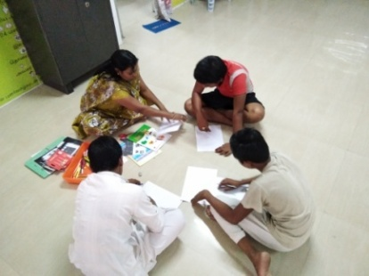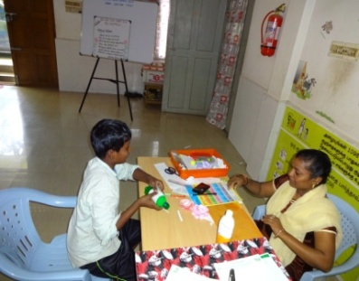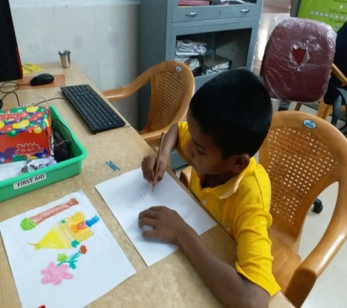
Boys Open Shelter run by Bro.Siga Social Service Guild supported by
Azim Premji Philanthropic Initiative
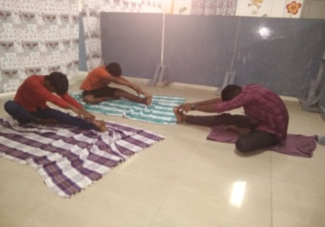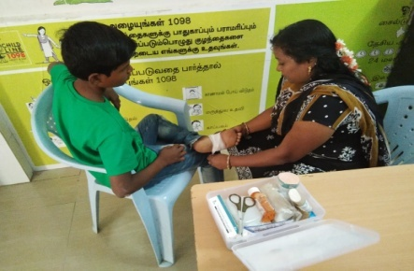
Boys doing Yoga First Aid

- HCL Foundation:
As if to congratulate us on our past impressive performance in the field of Pre School, the HCL came forward to grant us two projects- four Early Child Care Development centres in Chennai Gandhi Nagar Slum and two ECCD in Madurai slum. The project area was not our choice, but HCL specified the area. 200 children in the age group 1-6 years benefitted for ECCD Programme
The staff were recruited in Chennai and Madurai. They were invited to Delhi, for an exposure visit to similar programmes there. Two expert women from Mobile Crèches, Delhi, conducted twelve day training for the staff in Chennai. In Madurai since we have no footing there, a well established NGO by name the Antenna Trust in Madurai, conducted the interview for selecting staff. I would like to record here our indebtedness to the CEO of Antenna Trust Mr. Devamanoharan, Managing Director for all the help he had provided.
I announce that with this project, Bro.Siga Social Service Guild is elevated to the status of a State Level NGO, as it is working now in three Districts – Chennai, Solinganallur and Madurai. It is a matter for all of us to rejoice.
S.No | Activities | Chennai | Madurai | Total
1 | No. of staff | 17 | 13 | 30
2 | No. of ECCD centres | 4 | 2 | 6
3 | No. of Children benefitted | 100 | 100 | 200

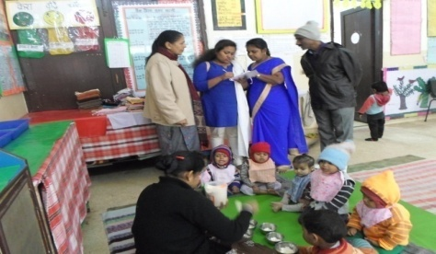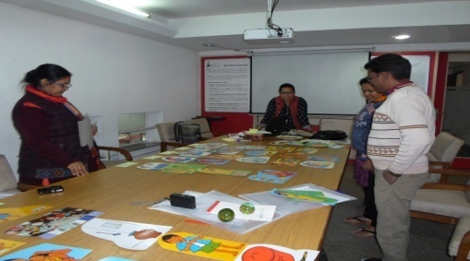
Mr. Sundaramoorthy, Director, BSSSG and ECCD staff –Learning Exposure visit to
Mobile Creche , New Delhi
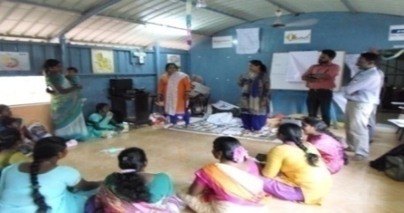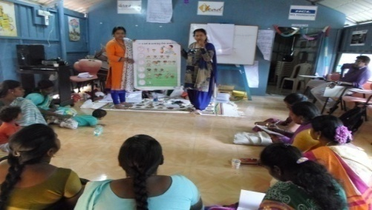
12 days Training to ECCD staff in Chennai organised by BSSSG and
Mobile Creches from New Delhi

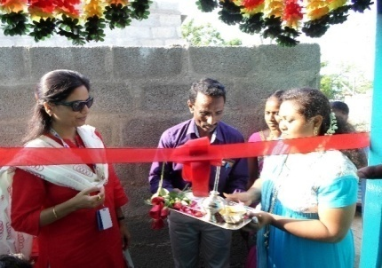
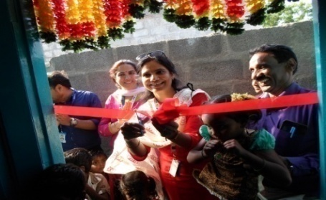
Inaugurated ECCD centres by Ms. Nidhi Pundhir, Director CSR Head and Ms. Simi Suri Lead Urban CSR from HCL Foundation
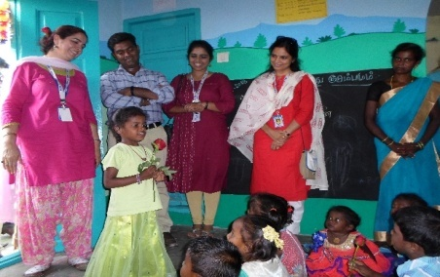
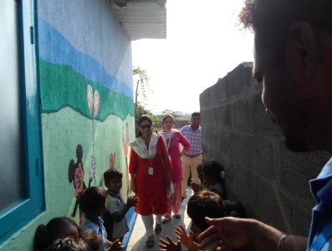
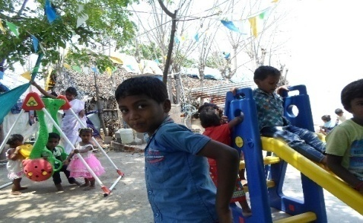
Ms. Nidhi Pundhir, Director CSR Head and Ms. Sumi Suri Lead Urban CSR from HCL Foundation Visited the ECCD centre in Chennai
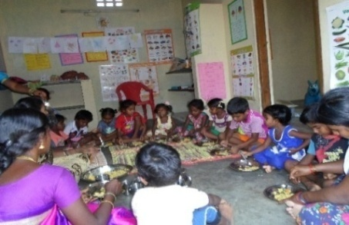

HCL My Community ECCD centres in Chennai Gandhi Nagar
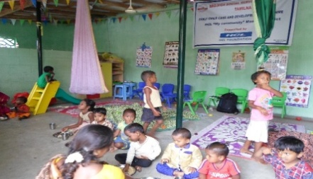
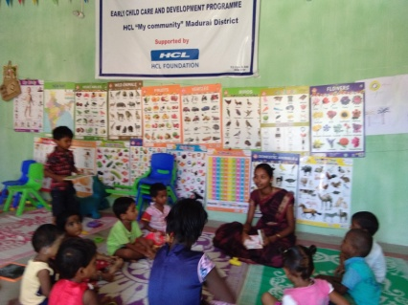
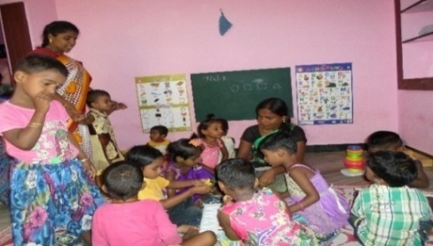
HCL My Community ECCD centres in Madurai Nethaji Nagar
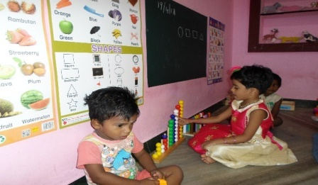
HCL My Community ECCD centre in Madurai, Pampatti Nagar
Now I am going to next section continuing projects
- TdH –NL Revolving Fund for Relief of Poor:
This was the only programme which continued with the support of Terre des Hommes Netherlands, our mentor, the memory of which we still cherish. Under this programme:

S.N | Activities | No. of Beneficiaries
1 | No. of vulnerable children participated in awareness programme | 1303
2 | No. of exploited/abused children received educational services- | 29
3 | No. of Community members with children participated in awareness raising activities | 698
4 | No. of community members with children participated in income generating | 38
5 | No. of SHGs formed | 7
6 | No. of members involved | 77
7 | No. of members received Revolving micro credit | 89
- 8 | No. of families increased income and assets | 291

Analysis of Micro finance supported for Business activities:
S.No | Month | Service |  | Trading |  | Production
 |  | No of beneficiaries | Amount | No of beneficiaries | Amount | No of beneficiaries | Amount
1 | April'17 | 7 | 1,60,000 | 23 | 5,90,000 | 36 | 6,20,000
2 | May'17 | 7 | 1,80,000 | 17 | 4,30,000 | 29 | 5,80,000
3 | June'17 | 11 | 1,65,000 | 34 | 8,25,000 | 12 | 3,60,000
4 | July'17 | 12 | 1,75,000 | 27 | 4,80,000 | 23 | 6,20,000
5 | Aug'17 | 5 | 1,50,000 | 13 | 4,20,000 | 40 | 6,70,000
6 | Sep'17 | 13 | 3,90,000 | 9 | 2,35,000 | 30 | 5,50,000
7 | Oct'17 | 2 | 70,000 | 10 | 2,90,000 | 24 | 7,20,000
8 | Now'17 | 1 | 40,000 | 18 | 5,55,000 | 28 | 6,00,000
9 | Dec'17 | 21 | 4,55,000 | 39 | 7,15,000 | 0 | 0
10 | Jan'18 | 9 | 1,85,000 | 22 | 4,20,000 | 26 | 6,00,000
11 | Feb'18 | 6 | 1,75,000 | 22 | 5,05,000 | 22 | 6,60,000
12 | Mar | 0 | 0 | 0 | 0 | 0 | 0
 | TOTAL | 94 | 21,45,000 | 234 | 54,65,000 | 270 | 59,80,000

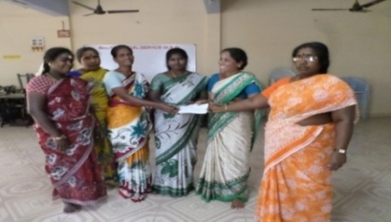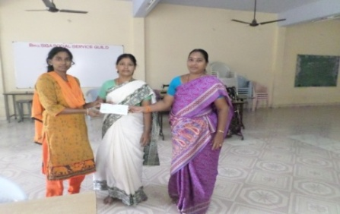
Relief of Poor Revolving fund Cheque issued to SHGs
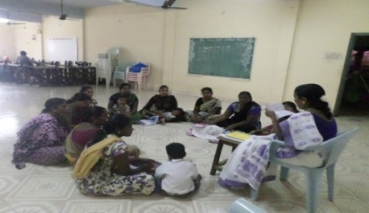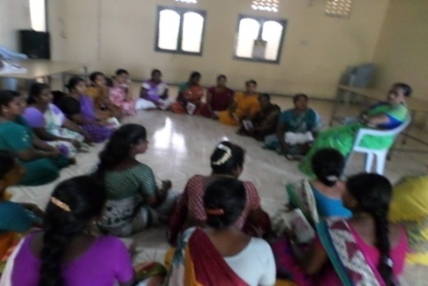
Meeting with Self Help Groups at BSSSG training hall
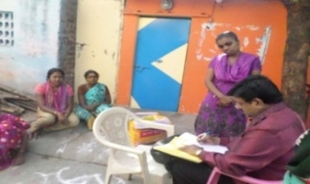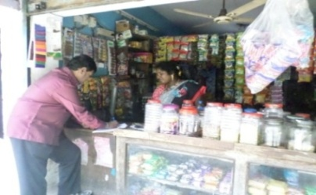
Mr. Sankarlal Auditor from Madurai -visited the SHGs and Beneficiaries
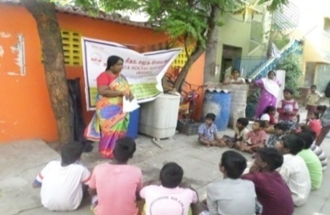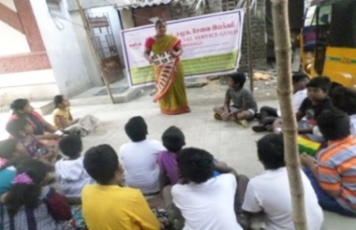
Children Club meeting organised by BSSSG staff at Filed level

- Intervention with Female Sex Workers:
This is a TANSACS aided project carried over from the previous year. It continued during the reporting period also.
The same team of staff continued. As per the records,
No. of Female Sex workers covered -1500
No. of High Risk Group Reached - 1810
No. of women received counselling -826
No. of Peer Educators training -24
No. of women tested positive –1

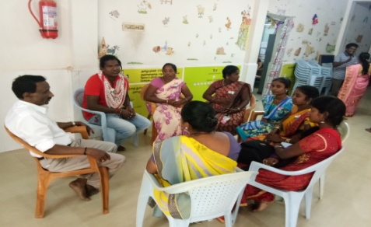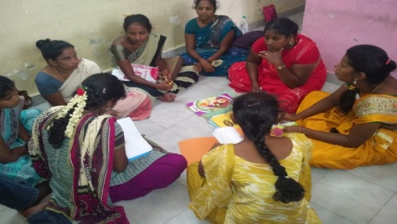
Staff Meeting Peer Educators Meeting
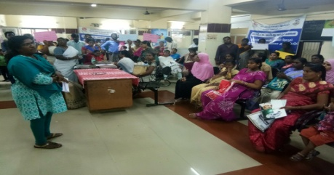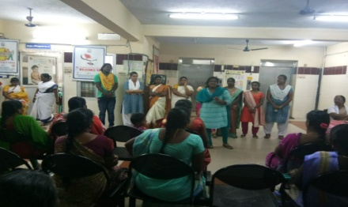
World AIDS Day Awareness Programme at Public Health Centre, Saidapet
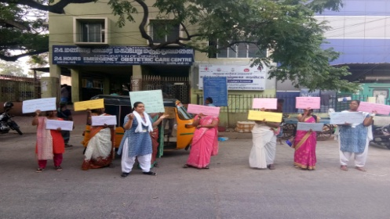
Rally – AIDS Awareness
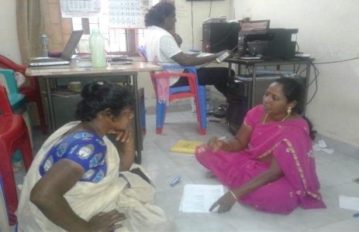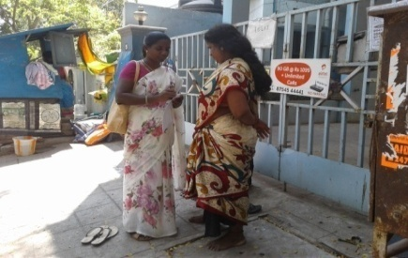
Hotspot meeting – Individual interaction
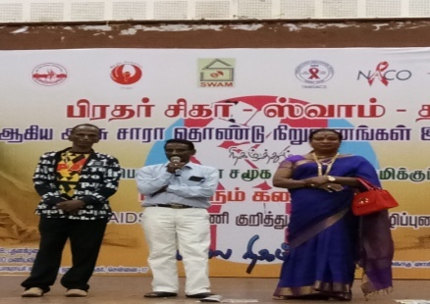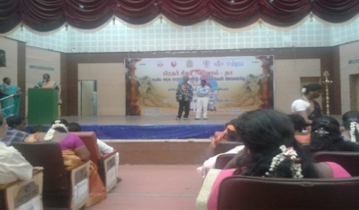
Community Event
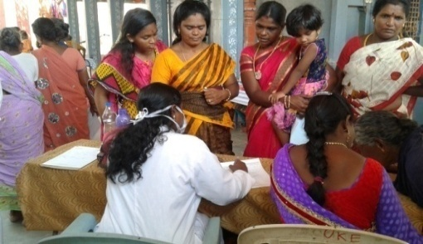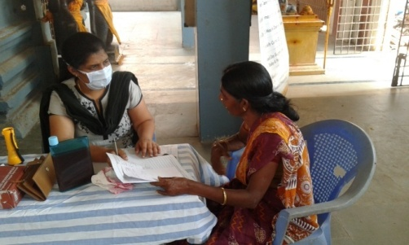
Health Check up to Target Community

- Railway CHILDLINE:
As I mentioned elsewhere in this report, the CHILDLINE India Foundation had sanctioned us, two projects and one was surrendered. The other was the Child Help Desk in Chennai Central Railway Station. It crossed the second successful year. The outputs prove the point. There was some change in the staff.
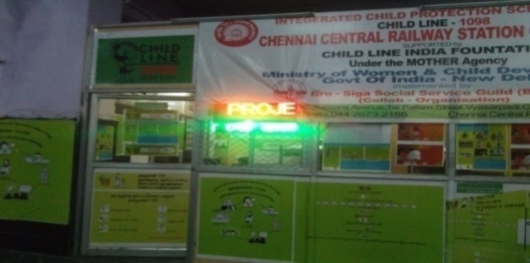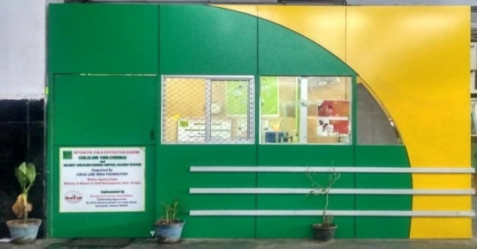
Child Help Line Desk in Chennai Central Railway Station

The total No. of children rescued –877 (Boys 768 Girls 109)
No. of children restored to parents/guardians: 622
No. of children referred to CWC – 255

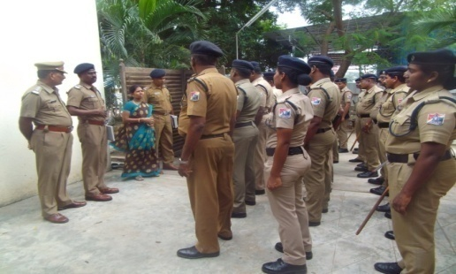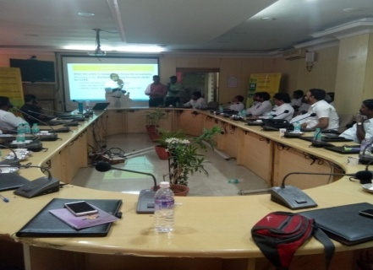
Awareness meeting to Railway Protection Force and Ticket Collectors
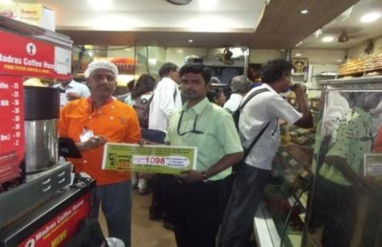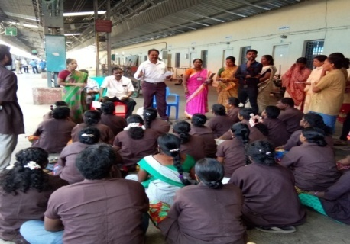
Sensitisation Meeting to Shop keepers and Sweepers
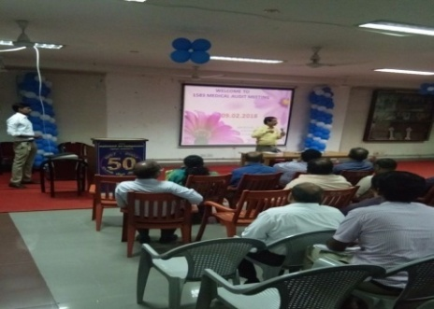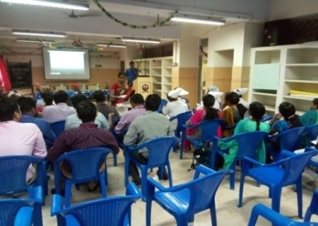
Resources Organization Meeting to Egmore Children Hospital and Stanley Hospital
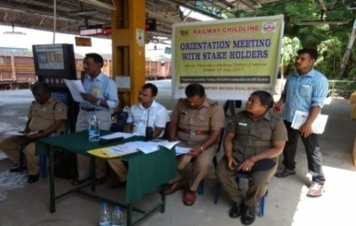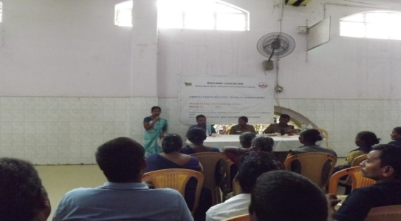
Orientation meeting with stakeholder Satellite unit Perambur Railway Station and Chennai Central Railway Station

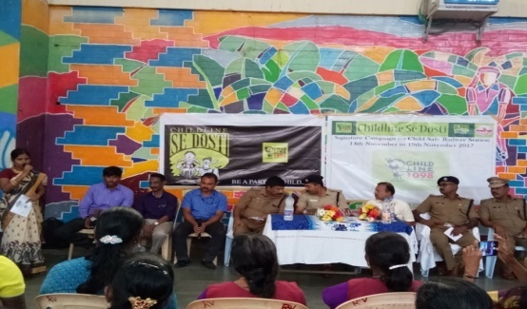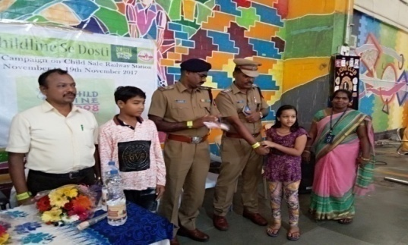
Celebrating CHILDLINE Se Dosti Week 2017 in Chennai Central Railway Station
- Tailoring Training
This is the only skill training to women, now in operation. You may remember that once, it was supported by the Rotary club of Madras Silver Beach. Now there is no support. I have submitted a request to some funding agencies in an attempt to mobilize funds towards the salary of the instructor.

No. of Students enrolled: 61
No .of students trained: 20
No. of students Job placed: 7
Self employed: 13

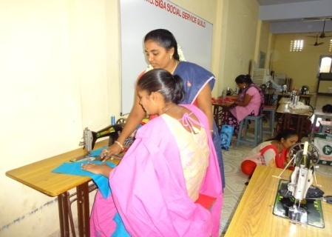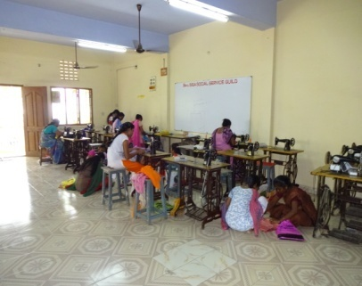
Tailoring Unit in Chennai
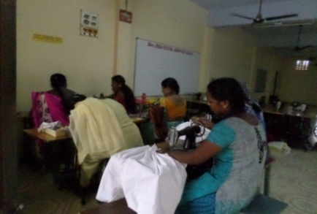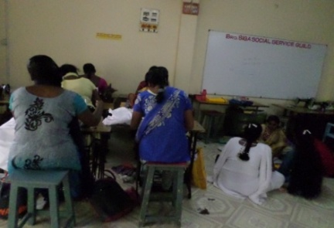

Other Programmes
- World Vision
We had established a rapport with World Vision India, a couple of years back. It was in connection with assistance to children of substance abusers, in slum. World Vision had adopted 63 children for support. Gifts like School bags, study materials and hygiene kit are given to them periodically. The programme continued during the reporting period also. Indoor and outdoor games materials were distributed.
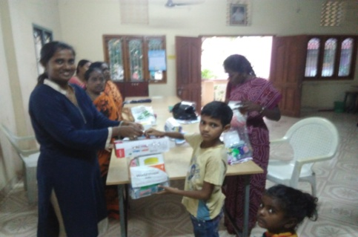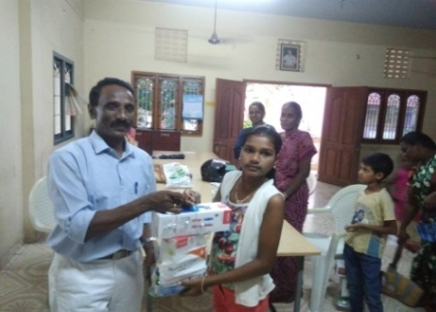
Hygiene kit donated by World Vision

- Labour Net Livelihood Enabling
The Labour Net Livelihood Enabling is a social enterprise focusing on skill training and other livelihood measures. Impressed by our past performance viewed in the website, it came forward to help the slum people. 3060 foot wear distributed for our target community and children.
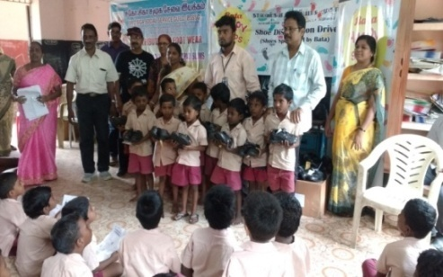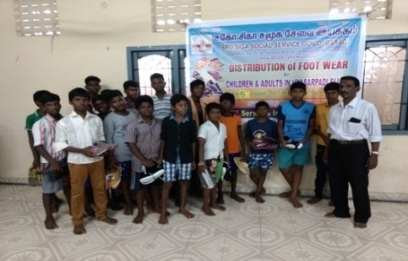
Distribution of Bata School Shoes in Government School
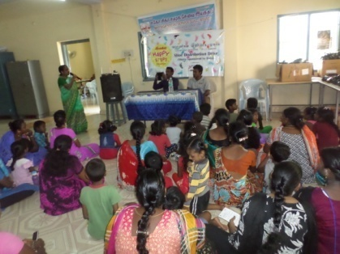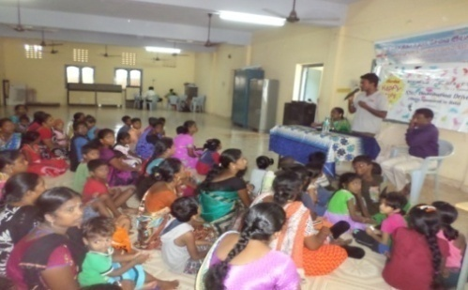
Distribution of Bata shoes in BSSSG Premises
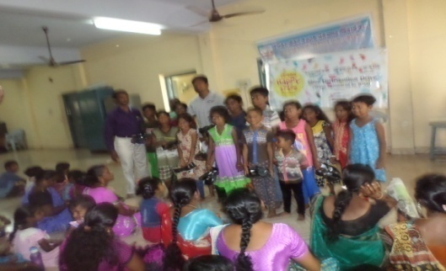
Chief Guest from Labour Net Distributing the Bata shoes

Praise Foundation:
It is not a funding agency. It is a body set up by the Corporate in Chennai. Its function is to screen NGOs, scan their worthy proposals and link NGOs to the Corporate. It is the Praise Foundation which got us a Project from MOL. Apart from it, Praise Foundation has arranged distribution of gifts from different sources, for the slum people. We are likely to get some solid projects through it. I register here our indebtedness to Praise Foundation.
- On 19th December 2017 - Distribution of Hygiene kit for Water bottles, Soap and Comb to 220 children supported by Prachi Ladies Circles
- The Van Gypsam donated 4 computers Desk with stand and Conference table
- 100 sarees donated by Chennai Ladies circles
- 100 baby diapers donated by Madras Esplanade Ladies Circles.

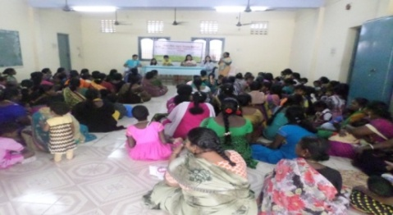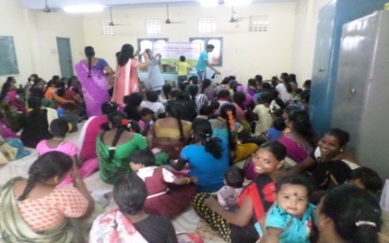
Distribution of Hygienic kit by Prachi Ladies Circles
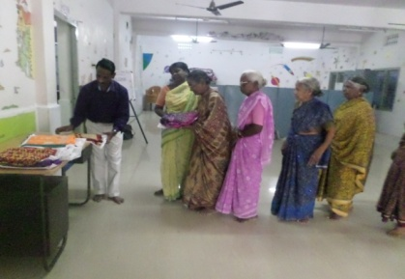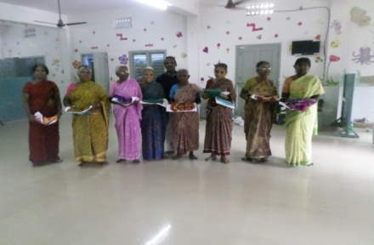
Mr. Sundaramoorthy, Director, BSSSG distribute the Sarees to Women donated by Chennai Ladies Circles
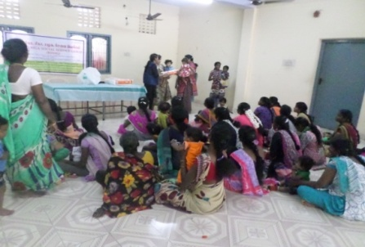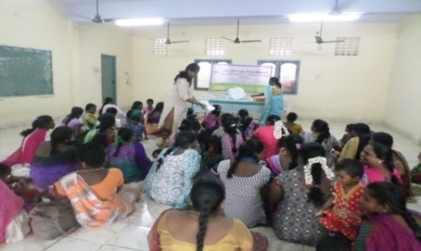
Distribution of Baby diapers donated by Madras Esplanade Ladies Circle

Projects in the Pipe line
There are some projects which are neither started nor completed during the period. But all formalities and desk works were completed during the period under review. I bring them under this head. I would like to mention first the Antenna Trust. It is a registered Indian Trust, with Head office in Madurai, involved in allotting microfinance to NGOs, with the robust backing of some foreign agencies. After negotiation it has agreed to allot us one crore of rupees to be rotated as micro finance to slum women. A MoU also is signed. It will start from the next fiscal year.

Now, I take up the second part of the Report of activities at Uthiramerur.

Uthiramerur Project
- Community College
It is our star programme in Uthiramerur block, Kanchipuram District. As in the previous years, the three faculties continued during the reporting period also – Diploma in Four Wheeler Mechanism, Diploma in House Electrician and Diploma in Computer Education.
Total student strength – 63 (Boys 61 Girls 2)
No. of students passed – 56
No. of students employed – 19

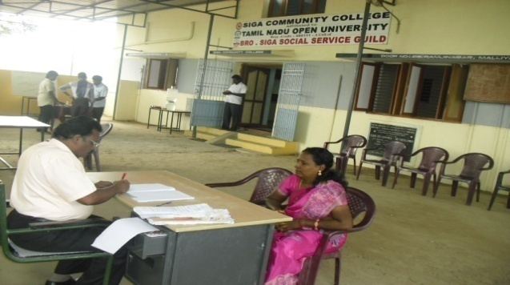
Siga Community College –Issued Applications
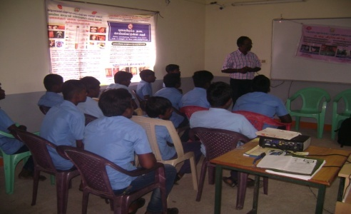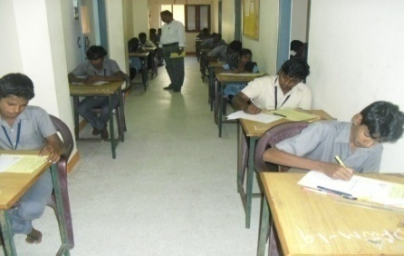
Sensitisation on TB Conduct examination by TNOU
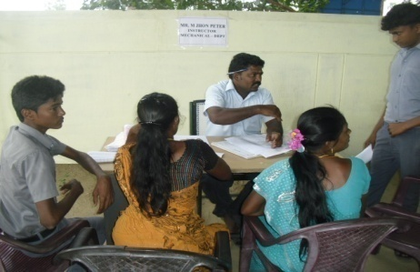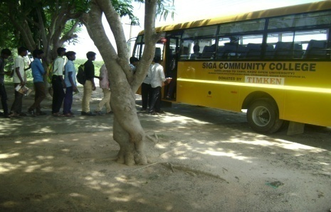
Parents Counselling Transportation facility for students
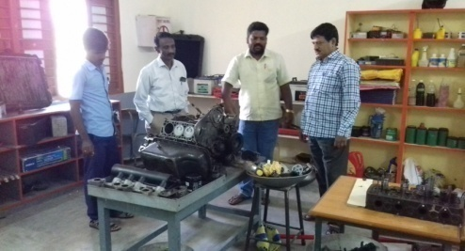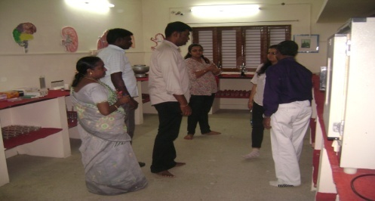
Pic-1 Mr. Sankarlal, Auditor from Madurai visited the Automobile classes.
Pic-2 HCL foundation from Delhi visited the Siga Community College
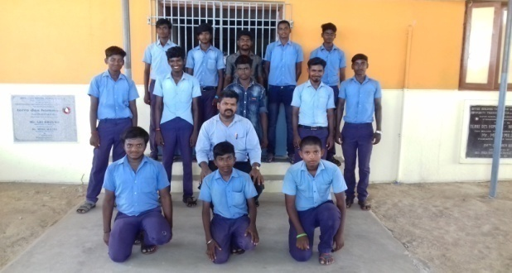
Siga Community College students with Instructor for Automobile

- Housing Scheme
As you know, Uthiramerur has a concentration of tribal communities. Prominent among them are the Irulas. Most of them live in low – thatched wall – less huts. Habitat for Humanity was magnanimous to construct houses for them. Repair work was done for 18 houses in Sengadu village.

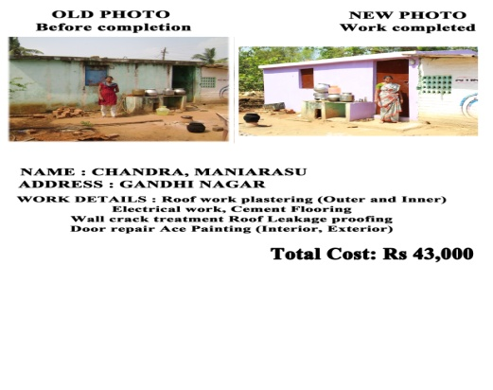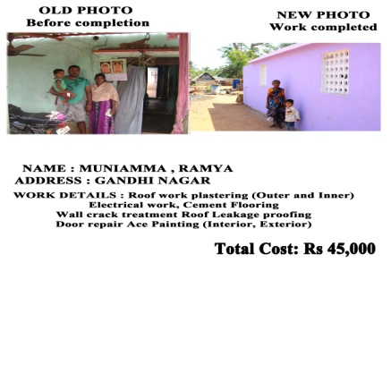

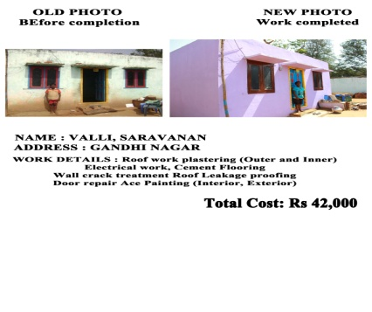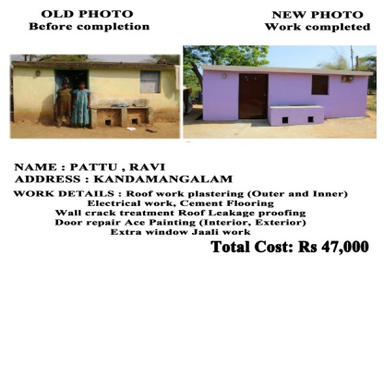
- Micro Finance
This programme started during the period of TdH-NL support continued during the period under review also. The outputs were steady.
No. of new SHGs formed – 13 SHGs with 169 members
No. of women received loan – 22 SHGs with 287 women
The total amount on circulation – 6370000/-

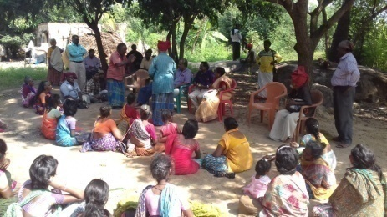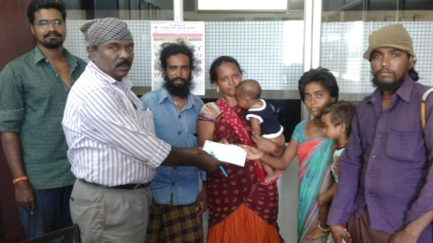
Community Meeting with Narikuravas families and Issued loan Cheque
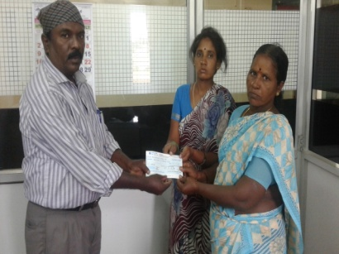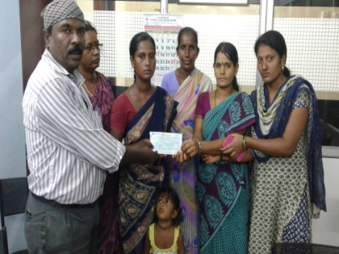
Relief of poor Revolving Fund Cheque issued to SHGs

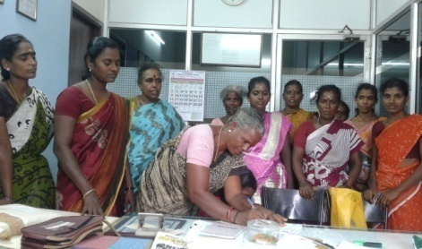
Orientation meeting with SHG members at BSSSG office

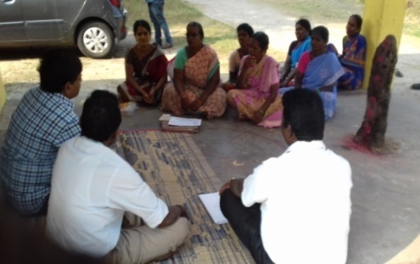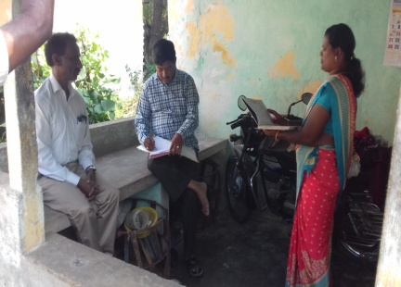
Field visit by Mr. Sankarlal Auditor from TdH-NL RF

I have come to the end of the Report. Before closing it, I register here our indebtedness to :
- All the funding agencies for their handsome grants
- The Executive Committee members for their co-operation
- All the staff for their tireless efforts, more particularly to the field staff who work in the Child Health Initiative Project.
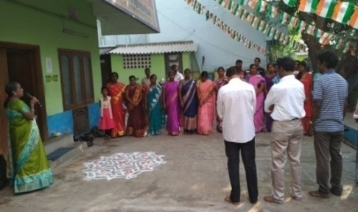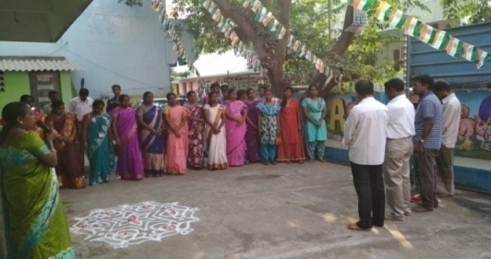
All Board Members and staff celebrating the Republic Day 2018
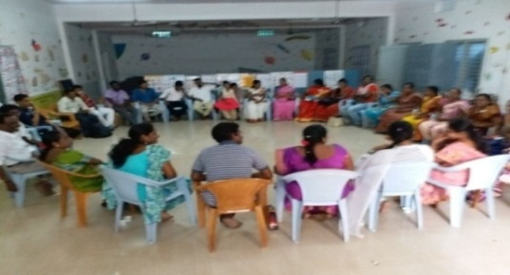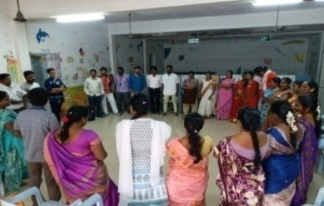
All Project Staff Review meeting at BSSSG training Hall

M. Sundaramoorthy
Founder Secretary

