Case Study: 1 (IN. 14007/33NH)
Case history of Karpagam, Maruthuvampadi Village:
Karpagam (37 yrs) w/o Chandran (50 yrs). They both are living in the village of Maruthuvampadi. They have 2 daughters and one son .One daughter is studying in Govt Arts College and doing the degree of B.sc Maths -2nd year and others are studying in Govt Higher secondary school. One Girl is studying 11th std and another one, son is doing 10th std. They faced lots of problems due to inconvenience of the house and lack of safety and security for the girl children also.
This large family was living in a hut undergoing all inconveniences. So they planned to build a new concrete house, but there was no finance. The parents were selling vegetables in the market and were struggling for subsistence. They got in touch with Bro. Siga Social Service Guild (BSSSG) working in the target village.
Karpagam approached the Community Empowerment Facilitator (CEF), joined SHG and then for a loan to start her business.
One day she approached the person of Community empowerment facilitator and discussed upon the situation of the house. So he promised to get Government House from Block Development Office and also spoke with the Panchayat leader for the House. After that she got Govt House.
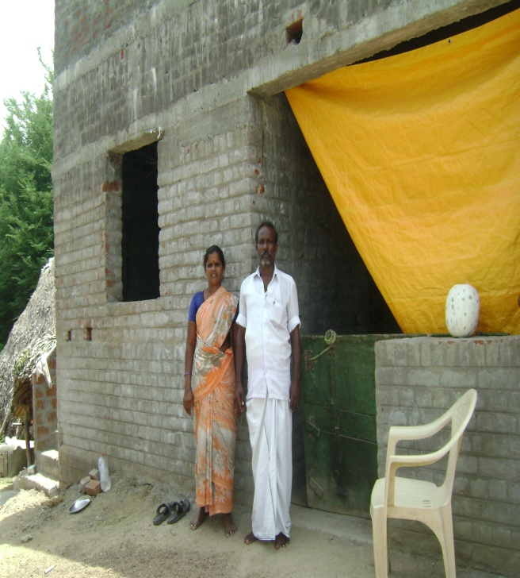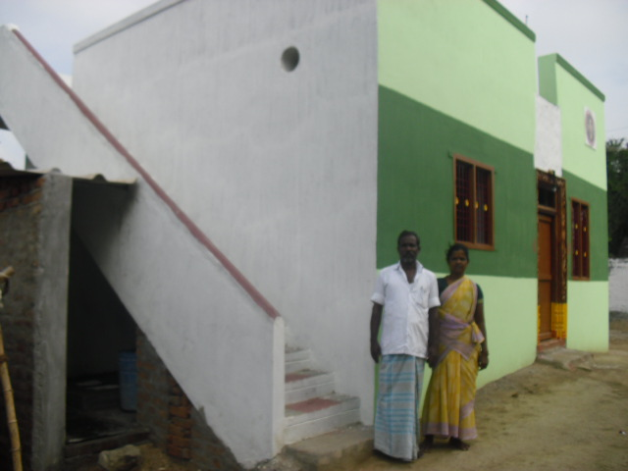
Before condition-Roofing level Karpagam with her Husband standing
before the completed concrete house.
After that they started to build a concrete house under the scheme Pasumai veedugal. She started and finished the level of Roofing. After that she finishes the money in her hand and went into depression and they sought help from the others. Her problem was identified by the CEF. Then, she knew about the Habitat for Humanity India New Housing program Through Bro Siga Social Service Guild and got loan amount of Rs.50,000/-.
With that amount she started the remaining work of Lavatory fitting & soak pit and fit a doors and windows. Now they finished the rest of the work and reached the final completion stage. Now they live in a decent concrete house about 350 sq ft in size with sanitation facility, providing safety and security, specially the privacy of the women and the girls in the family.
Karpagam says, “We are grateful to HFH India, Daimler FS (for their contribution in kind) and BSSSG for helping us to construct our home.”

