Case Study: 2 (IN. 14007/33NH)
Case History of Saritha Vengadesan, Village of Maruthuvampadi.
Case History:
Saritha is of 28 yrs and Vengadesan 33 years old. They both are living in Maruthuvampadi village. She has 2 daughters, studying at Child care center run by the Bro.Siga Social Service Guild. She was living in a joint family. In the joint family, totally there are 9 members. Her Husband is a cooli and he is the only bread winner of the family and earns 3000/- per month. This income was not sufficient for running her family. All of them were living in hut. It is a small house with the no power, no sufficient space to sleep and no sanitation facility and no safety and security for the women.
Intervention:
One day, Vengadesan approached the Community Empowerment Facilitator during is the time of field visit and he asked loan from him. So the CEF explained the procedures and norms of SHG. Then, he joined as a member of Kamarajar Men’s SHG and BSSSG provided loan to vengadesan. He started the dairy business and earned income of Rs.9000/- per month. Then they planned to build a new concrete house because Vengadesan’s brothers and sister grew up and had no facility to sleep. He approached again the person of Community empowerment facilitator and discussed upon the situation of the house. CEF guided the norms and conditions of the Govt Home schemes and shared about the principles and procedures of that. Then he met the Panchayat Leader Mrs.Neelaselvam and got the sanction to construct the Govt house. He started to construct the house and reached the level of Roofing. After that, they stopped the work because there was no money in his hand.
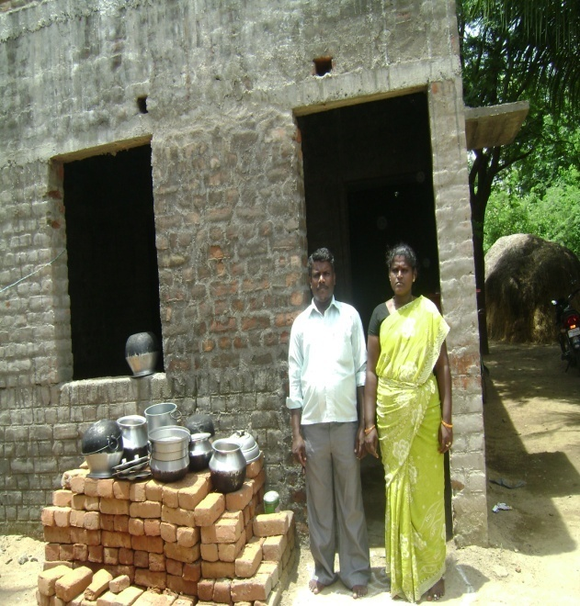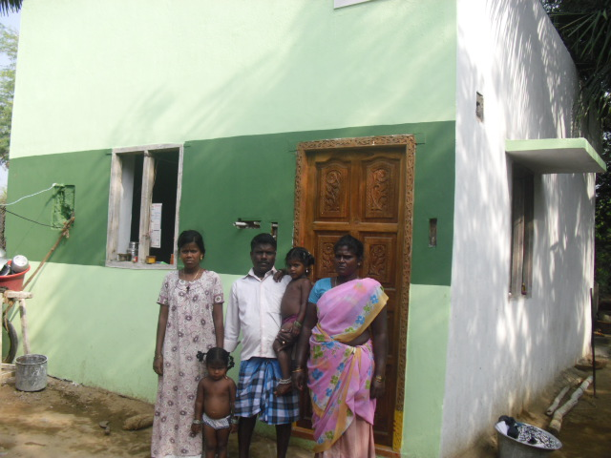
Before condition-Roofing level Vengadesan and his wife, Daughters-2 and his
Younger sister standing before the house of Pasumai veedu.
Then, he approached the Habitat for Humanity India’s housing program through Bro. Siga Social Service Guild and get loan amount of Rs.50,000/-.
Then she started the remaining work of Lavatory fitting & soak pit and fit a doors and windows. Now they finished the rest of the work and reached the last level. Now they live in a decent concrete house about 360 sq ft in size with sanitation facility, providing safety and security, specially the privacy of the women and the girl in the family.
Vengadesan says, “We are grateful to HFH India, Daimler FS (for their voluntary contribution in kind) and BSSSG for helping us to construct our home.”
Follow up:
The benefiary is under our monitoring and doing continuous follow up also.

