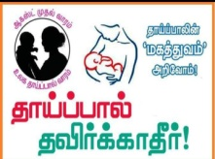 Breastfeeding Week Celebration-Chennai & Madurai
One week Breastfeeding celebration program was observed in two locations Chennai and Madurai districts of Tamil Nadu. Totally 113 pregnant ladies, lactating mothers participated. Knowledge on breast feeding benefits, storage facility for breast milk, private places available for feeding children at Railway Station and Bus stop, legal provision for carrying babies to job as per govt rule etc., passed on to the beneficiaries.
Professionals and Doctors cleared out the myth and misconception related to feeding milk, second child won't be conceived. This is wrong assumption. Symptoms of anemia, Position and hand washing methods before breast feeding & breast cancer are all explained in detail. We have displayed IEC materials of breast feeding and its benefits. Drama on importance of breast feeding was played by BSSSG staff team. A sensational Debate on significance of breast feeding one side and drawbacks of not providing proper nourishments to the infants other side was organized. 10 mothers participated and 5 on each side. We have provided Aachi Health Mix pockets to the mothers. 7 volunteers from HCLF were engaged in our Program and distributed Pre-test questionnaire to the participants on Breast Feeding and later they declared the answers. Participants themselves assessed their knowledge on breast feeding.

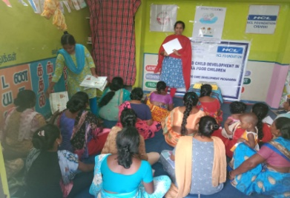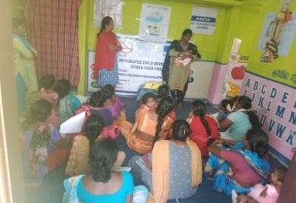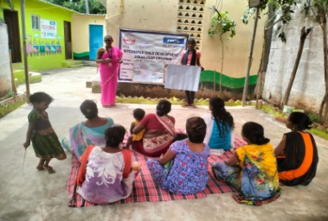
PCO Ms.Vanitha Explaining about Breast Feeding and teacher has doing demo of correct position of feeding
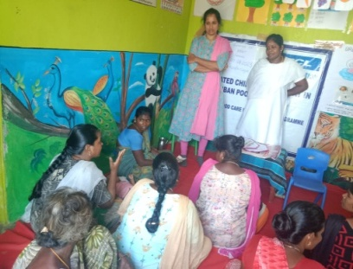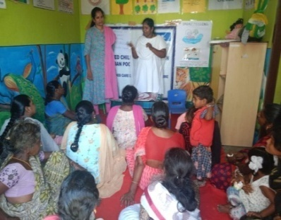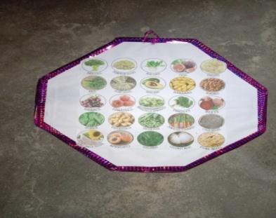
Participants raised questions Ms.Uma-PHC answering Chart prepared by teachers
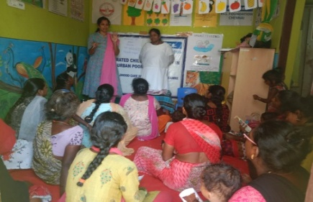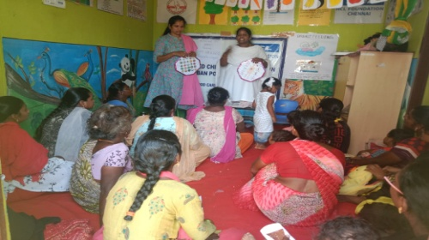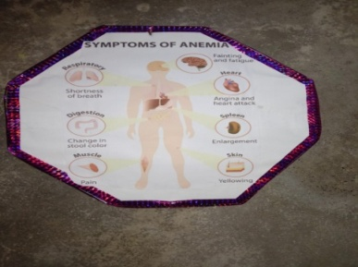
PCO Ms.Vanitha Explaining by using food chart and symptoms of anemia
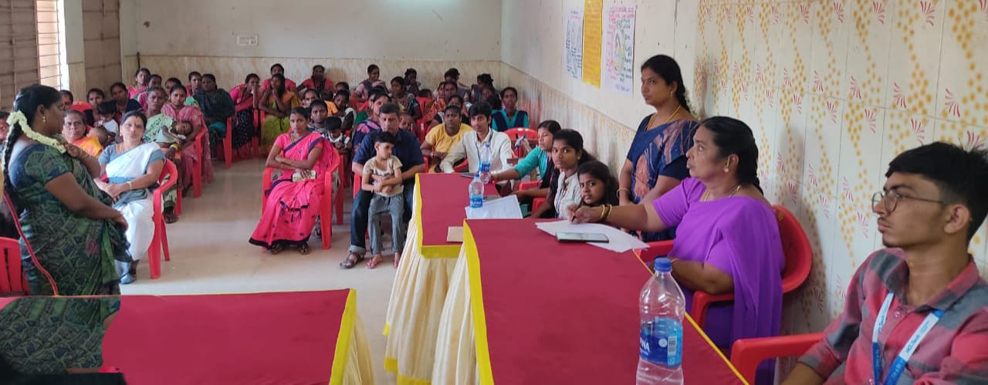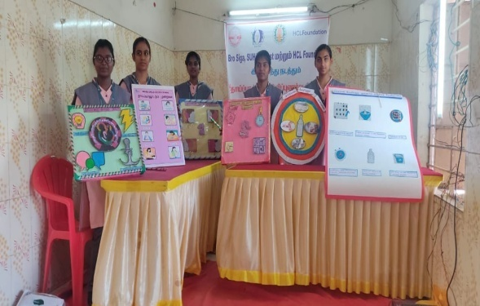
BSSSG & SUHAM jointly organized breast feeding week celebration Program at Community Hall,Keerathurai, Madurai
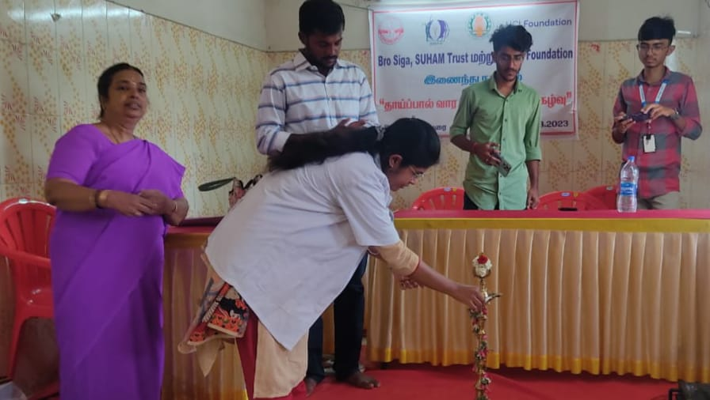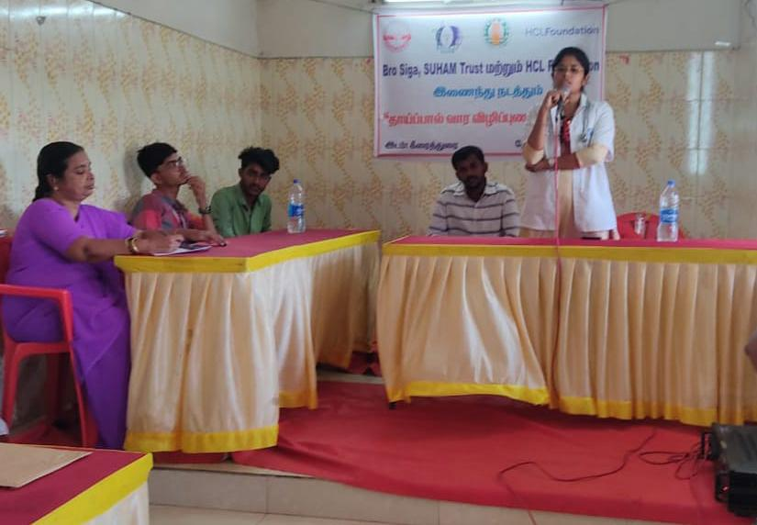
Medical Officer-PHC lighting the lamp and explained the benefits of breast feeding
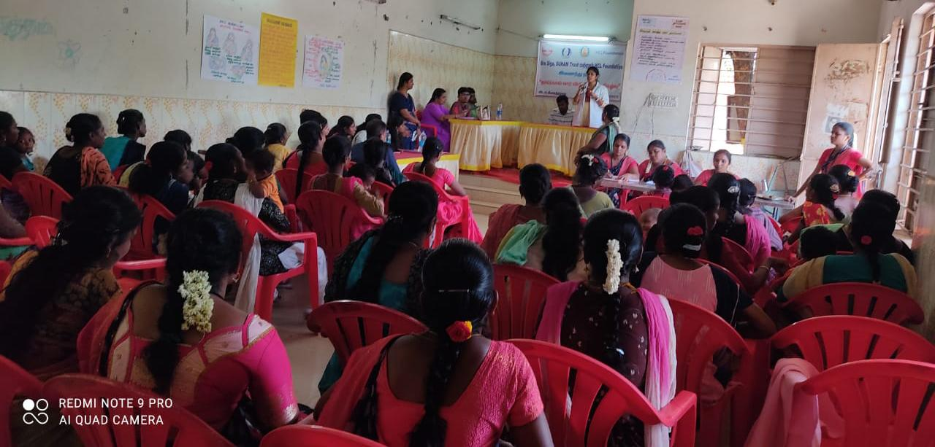

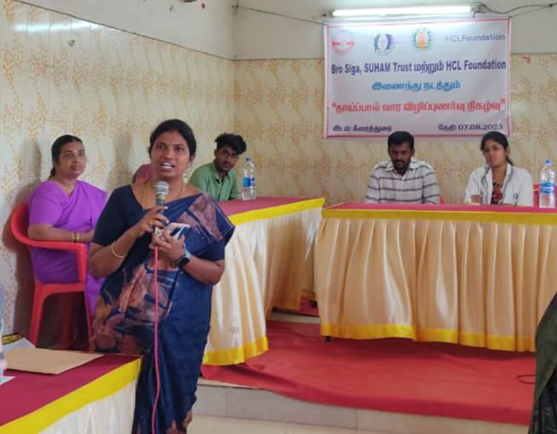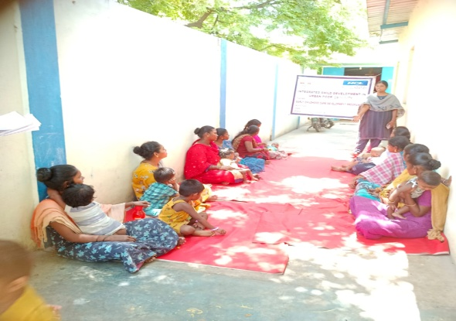
PCO-Ms.Suganthi welcomes all participants Debate organized
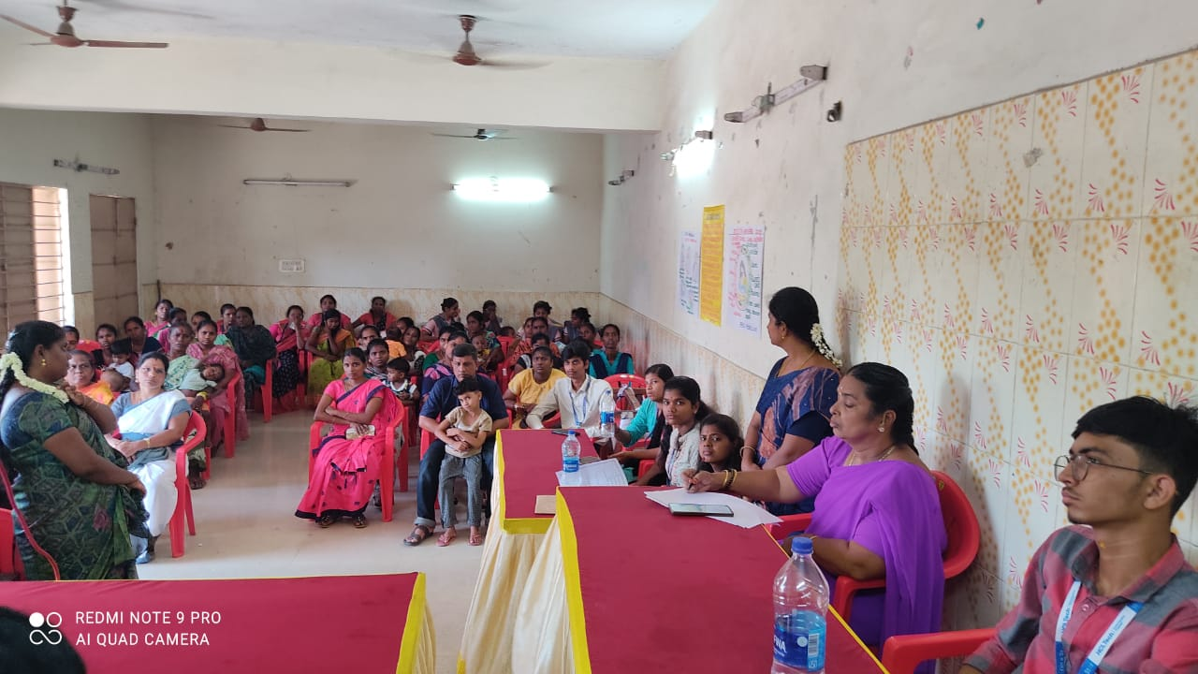
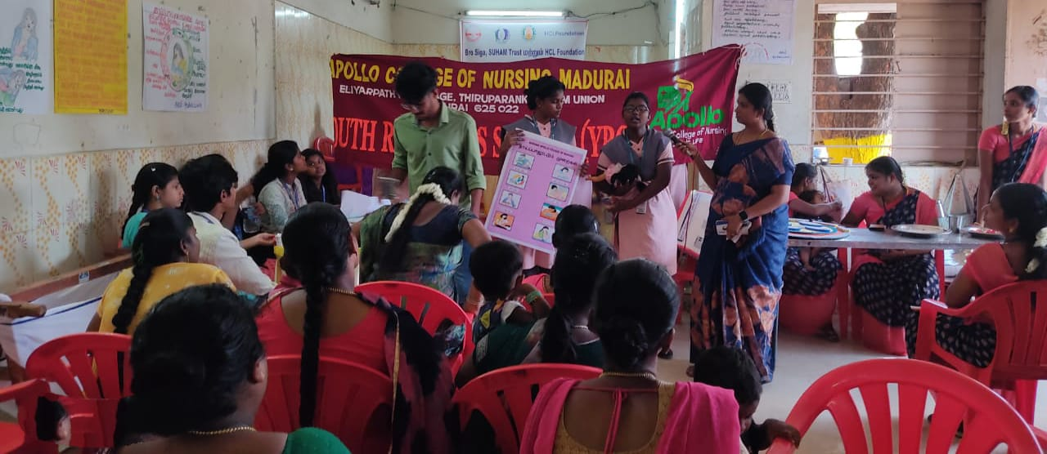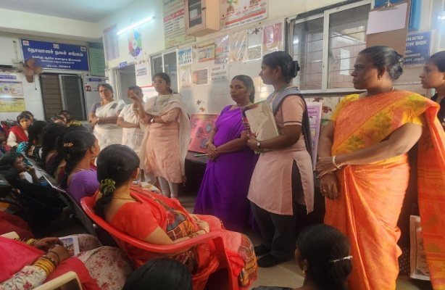
Displaying posters Session at local PHC
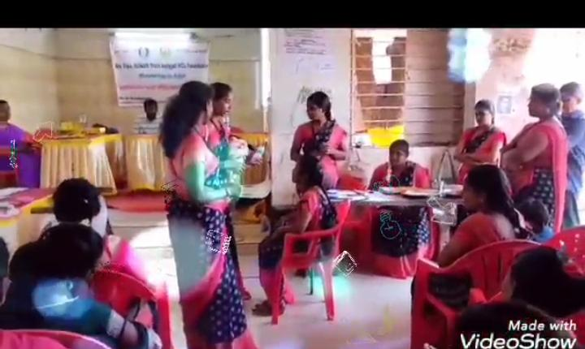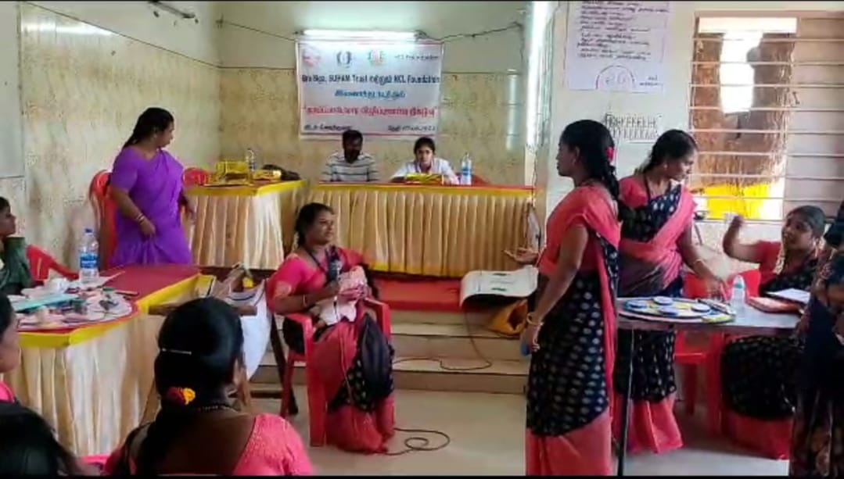
Drama played BSSSG Staff Team

